Task 1:

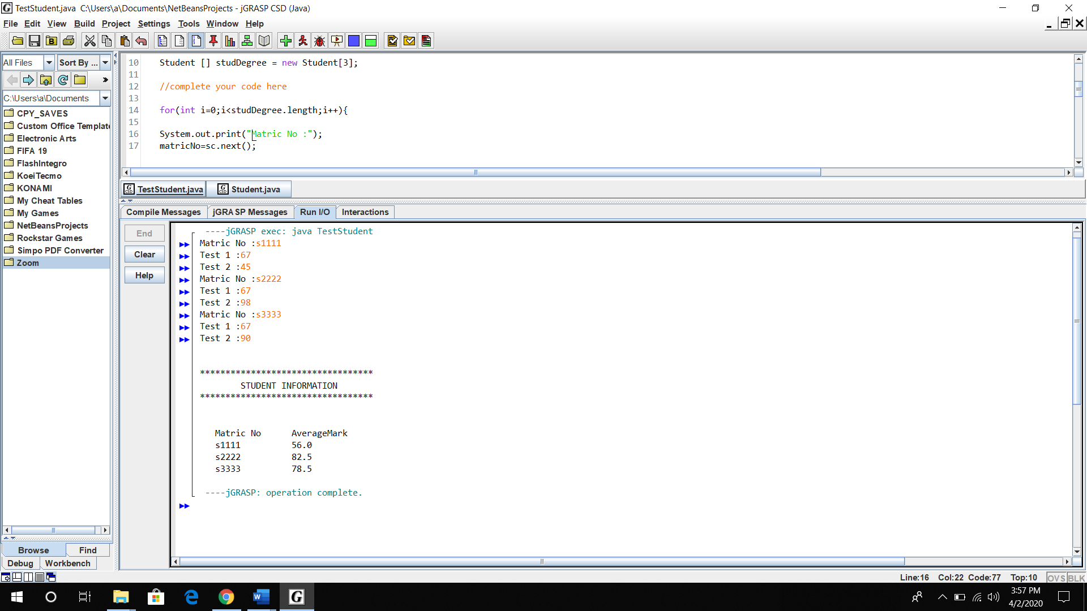

c)

|  |
| --- |
| Student |
| - String matricNo  - double test1  - double test2  - double averageMark |
| + Student(String matric, double ts1,double ts2)  + String getStudentInfo()  + void calculateAverage() |

d)

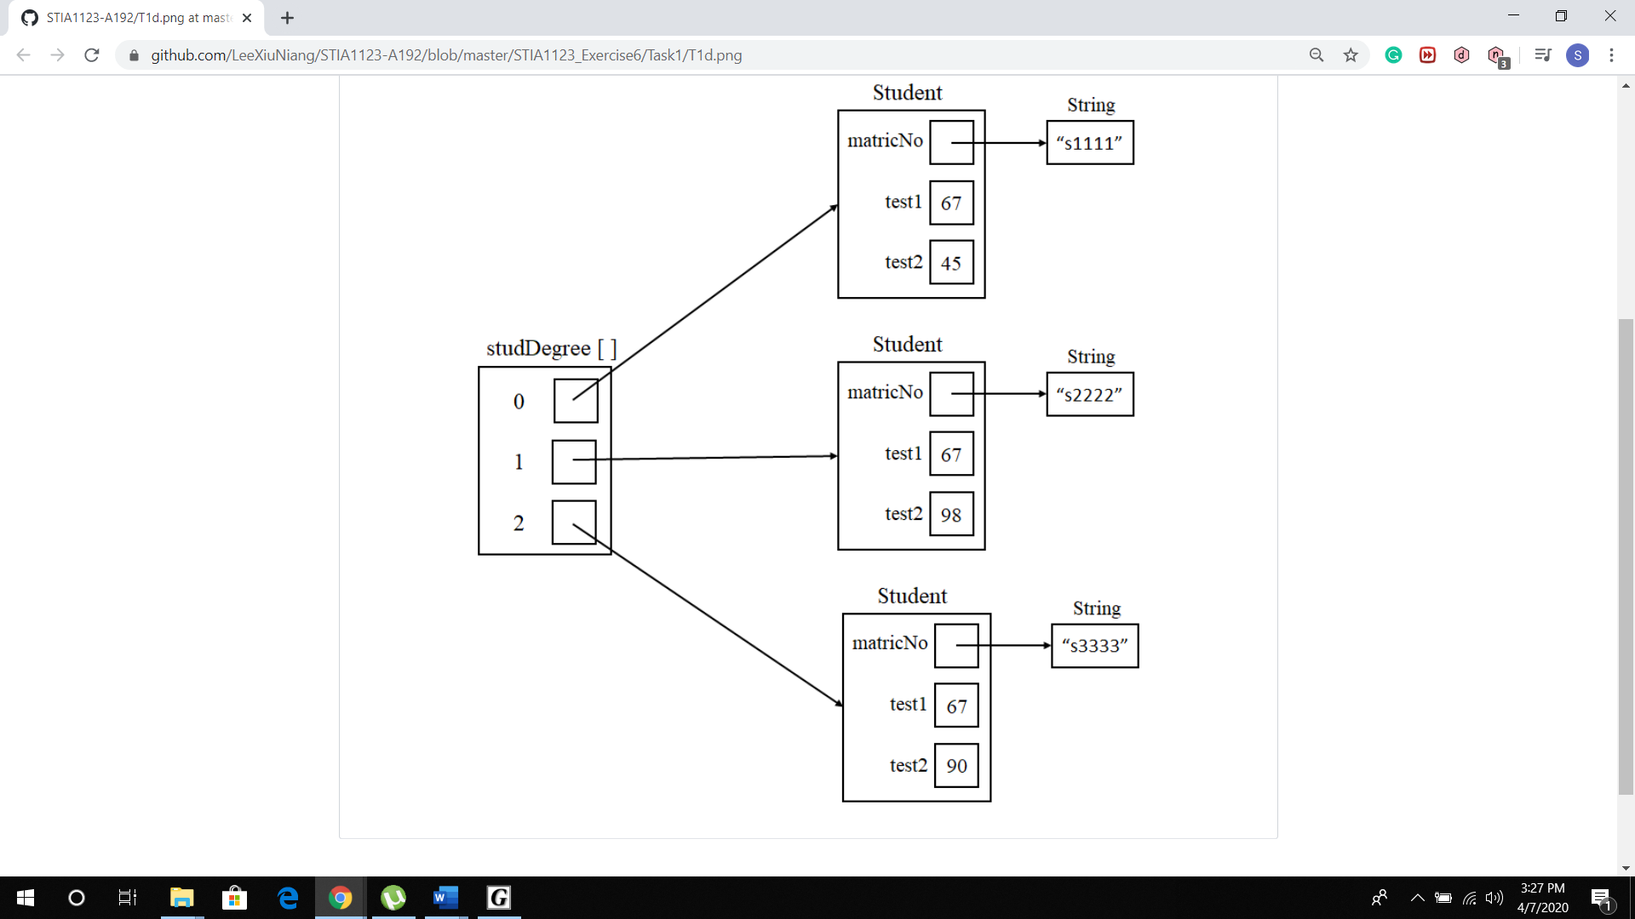

Task 2:

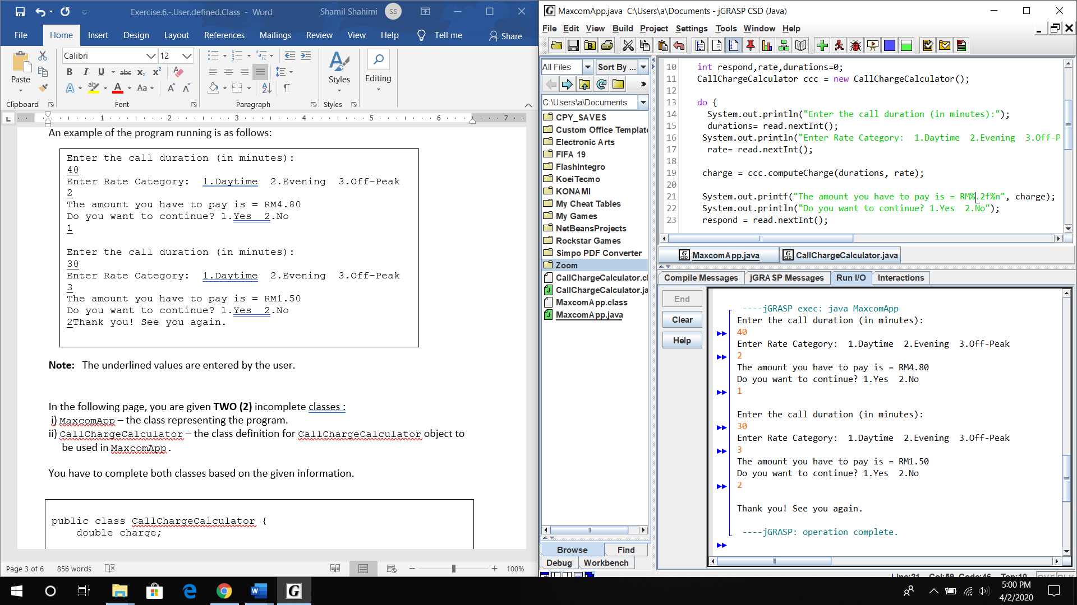

Task 3:

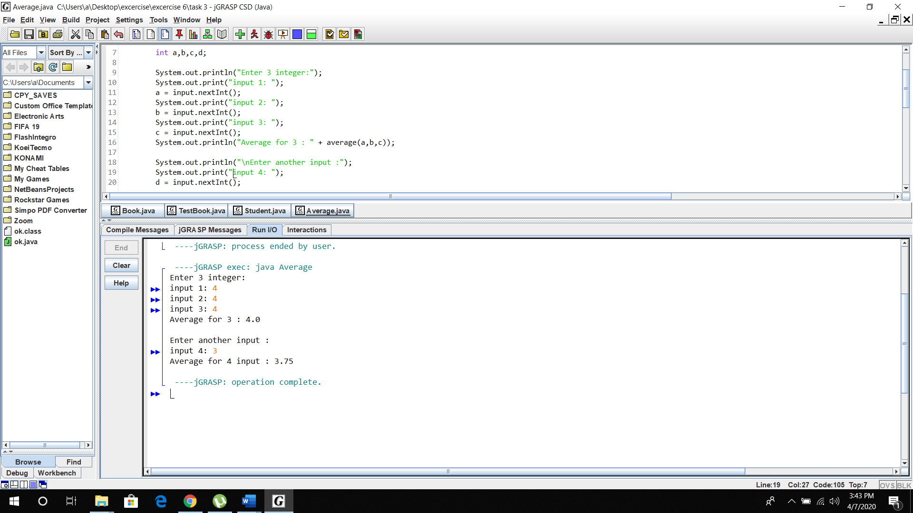

Task 4:

